
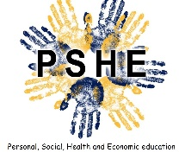

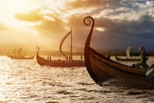
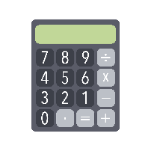


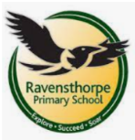

Art
This half term we will be looking at displacement in Art, focusing on artists who have been refugees including; Judith Kerr, Camille Pissarro and Frank Auerbach.

PE
Wednesday and Thursday
P.E. lessons will consist of Gymnastics were the children will be doing a combination of floor work and equipment.
Science
In Science we will be looking at further classification of living things to build on our knowledge from previous lessons. This will allow us to continue looking into the process of evolution and how this has changed the way we think about organisms.

Maths
In Math’s year 6 will continue to look at arithmetic including the four operations and fractions, decimals and percentages.
In addition we will be looking at statistics and geometry.

Writing

In writing we will be looking at nonfiction texts and how we can look at a range of formality within our writing. These will include a non-chronological report along with a formal letter.
Alongside this we will continue to look at the different grammatical features of our writing to prepare the children for their assessed pieces.

PSHE
In PSHE Year 6 will be taking part in different workshops about our bodies and staying healthy along with Drug Education.
RE
R.E. will focus around the religion of Hinduism and the diverse ways in which they build a sense of community.
Computing
In computing we will be looking at an introduction to Spreadsheets along with how to input and analyse data. We will also be continuing with Project evolve, learning about our online presence and how to staff safe when communicating virtually.

History
Year 6’s History topic is all about the Vikings. We will be looking at how the Vikings invaded Britain and looking into the culture of different Viking tribes.

Year 6
Spring Term 2

School: Ravensthorpe Primary School
Class name: Year 6 Sea and Martial Eagles

Reading
- Clarifying – understanding words / phrases
- Retrieval – finding information in the text
- Inference – using evidence and reasoning
- Summarising – finding the main points
- Practise – combining skills
This half term we are looking at weekly exposure to a range of genres to prepare for KS2 SATS, with a key focus on Retrieval and Inference.

