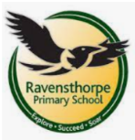

Reading
- Reading the following key texts as a class: Selection of non-fiction texts about Rainforests and the Ancient Mayans,
- Varjak Paw by SF Said.
- Great Britains by Imogen Russell Williams
- Know the meaning of new vocabulary
- Practices learning strategies using CRISP.
Clarifying, Retrieval, Inference, Summarising and practice.

Art and Design Technology
In D.T. we will be using pulleys and levers to create a video that shares a message.
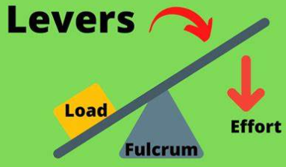
Science
We will be learning about the topic of: Sound
Sound will focus on: what sound is, volume, pitch and how we hear. 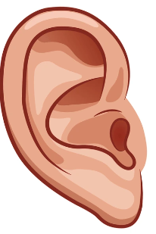 

Writing
We will be focusing on 2 styles of writing this term: Persuasive letter and Non-chronological reports. We will be learning how to use
Prepositional phrases to describe where something is.
Fronted adverbials to give information and make our writing interesting.
Expanded noun phrases to add information.
Subordinate conjunctions to extend our sentences.

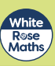
Maths
During this half term our focus areas will include:
exploring factors
fractions- counting beyond one whole, compare &
order mixed numbers, improper fractions and
and equivalent fractions
decimals – tenths as decimals and fractions,
hundredths as decimals and fractions

History
Our learning will focus on the topic of Ancient Maya, our learning will include: where and when the ancient Maya lived, who ruled the Maya, the beliefs of the ancient Maya, what the ancient Maya built and what the ancient Maya developed.

PSHE
In PHSE we will be learning about Risky Situations (reactions & strategies to deal with them) and Drugs (medicines, substances & support)
PE – Wednesday and Thursday
In PE we will be developing our skills in Dodgeball and Gymnastics.
RE
In R.E. we will be learning poverty & justice and
self-sacrifice from the view of Christians, Muslims &humanists and how different teachings encourage contributions to society.

Computing
In Computing we will be looking at changing digital images. In Keeping Safe we will focus on content and permission and recognising people’s feelings online.

Year 4
Spring Term 2

School: Ravensthorpe Primary School
Class name: Year 4 Western and Eastern Ospreys

