Diary dates:
Thursday 7th March: World Book Day
Friday 15th March: Red Nose Day
Thursday 21st March: Parents Café at 2:15pm.
Wednesday 27th March: Year 3 music performance at the Salvation Army
Thursday 28th March: Half term, day ends at 1:30pm.
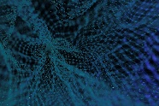

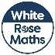
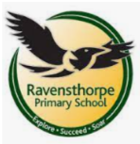
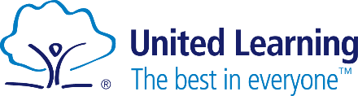
Art
Our art will be inspired by fairy tales and artists Anthony Browne and Quentin Blake’s work. We will be sketching and using clay to create alternative endings of famous stories.

By the end of this half term, children need to be confident in their 2, 5, 10, 3, 4 and 8 times tables and division Any extra practice at home is appreciated and needed!

Maths
This half term, we will be focusing on the first part of our fractions learning. Then we will be learning about mass and capacity.
By the end of this half term, children need to be confident in their 2, 5, 10, 3, 4 and 8 times tables and division Any extra practice at home is appreciated and needed!

Key Theme
Volcanoes

PE is on Tuesdays and Fridays. Please ensure children are wearing their house team top, a black hoody, leggings or joggers and black trainers.
Writing
This half term we will be focusing on non-fictional writing . We will be continue writing our non-chronological about Ancient Egypt and the create newspaper report.

We will focus on formal language, using a variety of sentence types and writing structures.

PSHE
Children will learn about healthy lifestyles. We research the effects of physical activity on the body and how we can have a balance diet.
RE: This half term we focus on Islam and where Islamic beliefs come from.
Music: Children will continue learning to play the recorder and have a performance at the Salvation Army on March 27th.
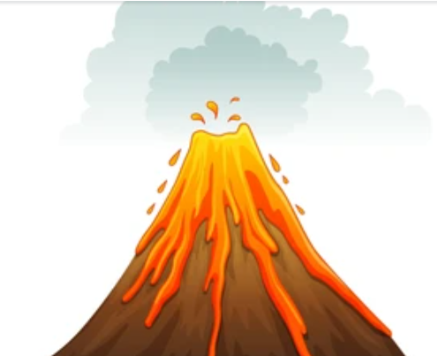
Geography
We will be learning about the structure of the earth, tectonic plates and how volcanoes are formed. We will also study famous volcanoes around the world.

Computing
In computing lessons, Year 3 will be focusing on learning what branching databases are and how to create one. We will be examining physical and on-screen databases and then creating an identification tool using a branching database.
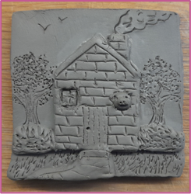
Reading
This half term we will carry on with our focus text ‘So you think you’ve got it bad’ exploring how a child’s life in Ancient Egypt is very different to a life of a modern day child. We will then be exploring the life of Tutankhamun and reading Flat Stanley and the Great Egyptian Grave Robbery.
Science
This half term, we are focusing on biology. We will be learning about what plants need to grow and stay healthy. We will also learn about plant life cycles.

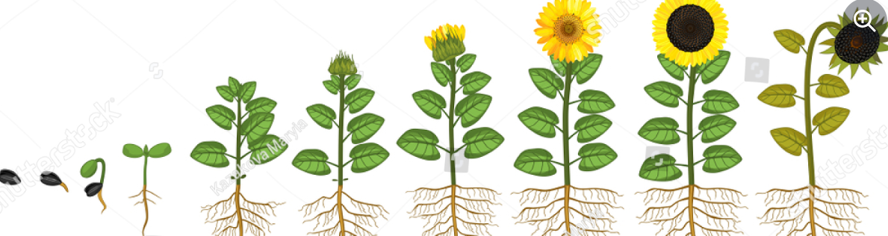

School: Ravensthorpe Primary School
Class name: Golden and Spotted Kestrels

