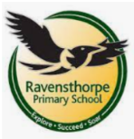

RE 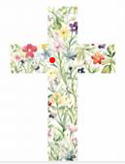
Why does Easter matter to Christians?
This is a study from Lent up to Jesus’ resurrection, the beliefs that Christians around the world hold and traditions that they follow.
DT
We will be looking at how an axle works.
Year 2 will be having a ‘Parent Café’ on Thursday 14th March – details to follow – where you will have the opportunity to help make a moving vehicle with your child.

Music
Miss Karolina will continue to teach year two how to play the ukelele.
This is a weekly session where each child gets to play their own instrument and learn chords and songs that they play together!

Maths 

This term we will be continuing with multiplication and division learning our 2’s. 5’s and 10 times tables. We will also be working towards understanding different measures.
Please consolidate this learning at home by logging on to TTRockstars at least twice a week.

History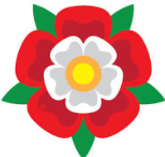
In History our learning will be about Henry VIII and his wives! We will construct a diorama to display our knowledge of his marriages.
We will also be delving into his life and discover some facts that link him and his family to our local area!

Reading 
RWI program is a daily lesson that features all aspects of reading. Our class book this term is The Queen’s Token by Pamela Oldfield.
.Please encourage your child to read at home! Reading improves concentration and memory, enhances vocabulary and increases imagination and creativity.

In class our book is The Queen’s Token by Pamela Oldfield.

Writing
Our writing is based on the story Six Dinner Sid by
Inga Moore. We will be writing a diary entry.
Later on in the term we will be writing instructions
and a non-chronological report.
We are focusing our efforts on making the correct
joins in our handwriting too.

PE – Monday and Friday
In PE year two are learning gymnastics. Please ensure that PE kit is worn on PE days with long hair tied up and earrings covered or removed.

PSHE
For PSHE we will be starting to think about money and finances.
We will continue to learn how to keep safe online.

.

Year 2
Focus topic: Henry VIII

Science
Our topic is ‘Living things and their habitats’ where we will be investigating all seven life processes.
We will be taking our learning outside when looking at the life-cycle of plants. 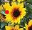

School: Ravensthorpe Primary School
Class name: Year2 Goshawks and Sparrowhawks

