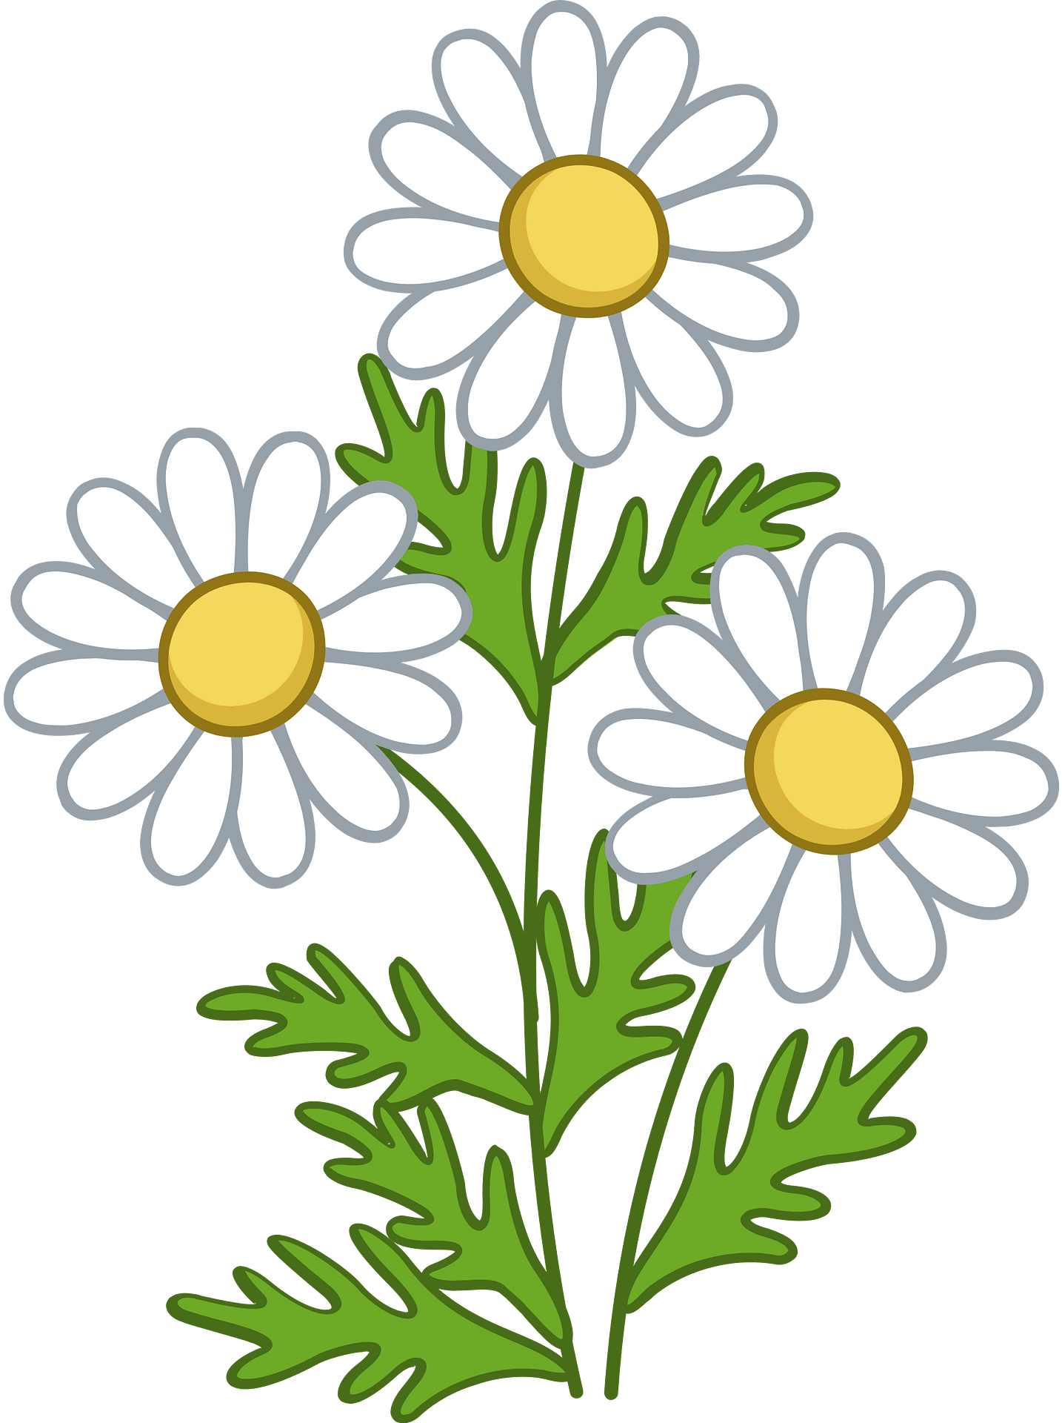


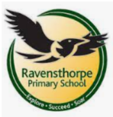

In our DT lessons we are learning to create moving pictures using simple linkages (levers and sliders). We will be working on how to measure accurately and how to use scissors safely to create our project. This is a fun activity that we can do at home. Get ready to be amazed by their creative and imaginative creations!

Science
We are exploring the fascinating world of plants. We will focus on identifying and naming common plants, as well as describing their basic structures. Your little ones will learn all about the wonderful world of flora and its essential role in our environment. Let's grow together!

Maths
We are learning Place Value to within 50! Counting at home will help us be more confident in our Maths work.
We will then move onto Length and Height, learning how we measure things to find out what is longer/higher. Followed by Mass and Volume, learning how to measure capacity and compare capacity.
Remember to log onto Numbots to help practice and secure our Maths skills!

RE/ Music
We our exploring our musical talents this term. We will have the opportunity to sing, play instruments, listen to a range of music and compose our own music, improvising a beat to a rhythm.

Writing
At the end of last term, we read ‘Lost and Found’ and learnt how to create instructions using imperative verbs. At the beginning of this term we will be continuing to write instructions on how to build a raft to help the boy find the penguin’s home.
After we will be linking our learning to our History topic and looking at the famous Amelia Earhart. We will be creating a non-chronological report about her incredible life. We will remember to use our capital letters, finger spaces and full stops! The more we practice the better we get!

DT/Art

Computing
We will learn about data and information. They will start by grouping objects and labelling these groups. We will also learn to count objects before and after grouping them. We will then use our sorting skill to answer questions using data.

PSHE
We are all about promoting healthier and safer lifestyles. We will be learning how to manage safety and risk in our daily lives. Thinking about what is safe and unsafe and who we can ask for help. Together, let's be empower to make smart choices and stay safe.
PE – Monday and Thursday
In PE we are learning about Gymnastics and Targeted Games. Enhancing our coordination, strength, teamwork and develop our key motor skills.
History
In our History lessons, we explore the fascinating world of transport! We learn about how transport has evolved on land, sea, air, and even in space. We also focus on the important contributions of key individuals in shaping these modes of transport.

Year 1
Spring Term 2

School: Ravensthorpe Primary School
Class name: Year 1 Red Kites and Yellowbill Kites

Reading – Talk Through Stories
We are exploring some exciting books;
- The Bog Baby, a tale about two girls discovering a creature in a pond, should they tell their Mum what they have found or keep it a secret?
- The Comet, a beautiful, magical and heartfelt picture book about moving home and exploring new lands.
- Chocolate Cake, a long children’s poem that describes how much a young boy loved chocolate cake. YUM!

