

Understanding the World
- Plant a bean and keep a bean diary
- Go on a spring discovery walk, explain the effect of the changing seasons e.g.: leaves turning green, new baby animals, warmer weather.
- Use checklists to go on nature hunts looking for plants including flowers, insects and spiders.
- Talk about what plants need to grow.
- Talk about the foods we eat and what keeps our bodies healthy. Make fruit kebabs.
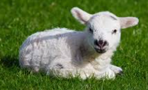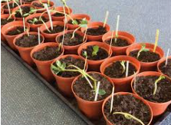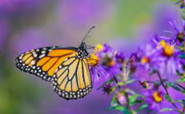

Physical Development

- Understand the importance of healthy eating with various activities e.g.: making fruit salad/fruit smoothies.
  - Revise and refine the fundamental gross motor/fine motor movement skills they have already acquired.

Maths
- Time: Use the vocabulary yesterday, today and tomorrow
- Recognise and represent 9 and 10: Identify representations of 9 and 10, Begin to explore the composition of 9 and 10
- Compare numbers to 10
- Number Bonds to 10: Explore number bonds to 10 using real objects
- Shape and Spatial Reasoning: Select, rotate and manipulate shapes in order to develop spatial reasoning skills. (3D)
- Continue, copy and create repeating patterns: Copy and continue repeating patterns with varying rules
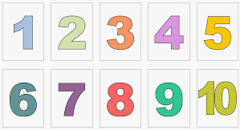

Expressive Arts and Design
- Explore mixing colours. Paint a butterfly and explore symmetry.
- Recreate pictures from The Extraordinary Gardener using different tools and materials.
- Carry out observational drawing using different media.
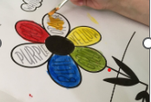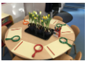
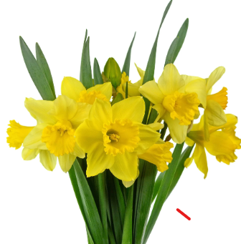SPRING IN OUR STEP
Personal, Social and Emotional Development
- Show confidence, resilience and perseverance in the face of challenge.
- Think about the perspectives of others.
- Consider different ways to keep ourselves calm.


Writing
- Form lower-case and capital letters correctly.
- Write short sentences using phonics skills.
- Label parts of a plant.
- Write simple character descriptions.
- Make own book about Spring.
- Sequence stories with pictures.
- Orally compose and write instructions for planting a seed.

Communication and Language
- Understand and use new vocabulary introduced through non-fiction texts and stories relating to spring, gardening, seasons and life cycles.
- Use talk to help work out problems and organise thinking and activities explain how things work and why they might happen, for examples when discussing the life cycle of a butterfly.
- Encourage children to ask questions to deepen their understanding.

Reading
- Reading key texts as a class including:
- The Very Hungry Caterpillar, The Enormous Turnip and The Extraordinary Gardener.
- Read simple phrases and sentences made up of words with known letter–sound correspondences and a few exception words.
- Learn new vocabulary relating to Spring and the life cycle of different creatures.
- Read simple character descriptions
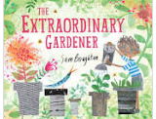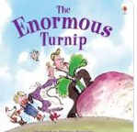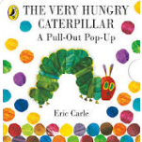
School Ravensthorpe Primary School
Class name Snowy and Barn Owls

