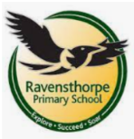

Computing, Keeping Safe & PHSE
In PHSE we will be learning about Risky Situations(reactions & strategies to deal with them) and Drugs (medicines, substances & support) In Computing we will be looking at changing digital images and different forms of programming. In Keeping Safe we will focus on content and permission and recognizing people’s feelings online.
R.E. & MFL
In R.E. we will be learning poverty & justice, self-sacrifice from the view of Christians, Muslims & humanists and how different teachings encourage
contributions to society.
We will be learning Spanish based on themes
including colours, greetings and counting.
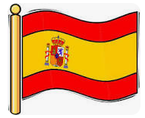
History and Geography
Our learning will focus on the topics of Tropical Rainforests and Ancient Maya
Tropical Rainforests will include: what are tropical rainforests, layers of the tropical rainforest, why rainforests are important, rainforests under threat and protecting the rainforest
Ancient Maya where and when the ancient Maya lived, who ruled the Maya, the beliefs of the ancient Maya, what the ancient Maya built and what the ancient Maya developed.

Science
We will be learning about two different topics during the term: States of Matter and Sound
States of Matter will focus on: the properties of solids, liquids and gases, changing states of matter, investigating evaporation and the water cycle
Sound will focus on: what sound is, volume, pitch and how we hear. 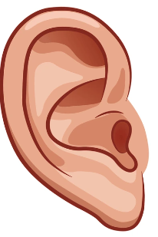 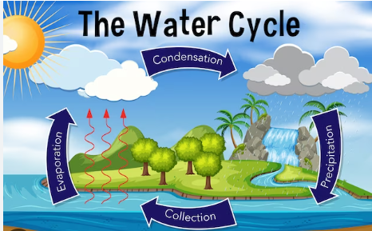

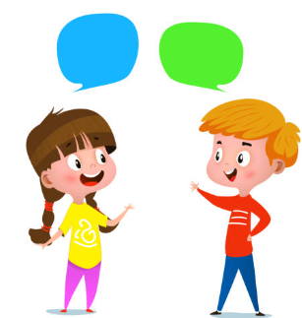


Maths
During this term our focus areas will include:
exploring factors
multiplying & dividing by 10, 100 & 1,000
formal written multiplication with up to three digits
measures – length and perimeter
fractions- counting beyond one whole, compare &
order mixed numbers, improper fractions and
and equivalent fractions
decimals – tenths as decimals and fractions,
hundredths as decimals and fractions

Key Themes
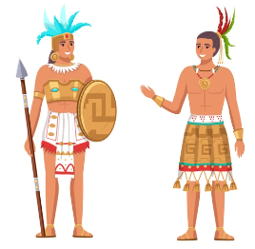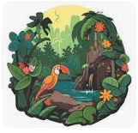

Writing 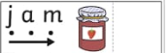
- Innovate a story using a story map (change elements to make it your own).
- Write simple labels.
- Write words using sounds taught in phonics.
- Write a simple list using phonics to sound out words.
- Say simple captions and sentences out loud and write these using phonetically plausible sounds.

Reading
- Reading the following key texts as a class: Selection of non-fiction texts about Rainforests and the Ancient Mayans,
- What the Macaw Saw by Charlotte Guillain
- Varjak Paw by SF Said.
- Great Britins by Imogen Russell Williams
- Know the meaning of new vocabulary e.g.: Canopy, Vegetation, lush dense.
- Practices learning strategies using CRISP.
Clarifying, Retrieval, Inference, Summarising and practice.

Music, Art and Design Technology
- Make simple predictions about what will happen next.
- Retell a story using both actions and words.
- Listen carefully and learn rhymes, poems and songs.
- In DT we will be looking at sustainable systems

School: Ravensthorpe Primary School
Class name: Eastern and Western Ospreys

