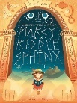
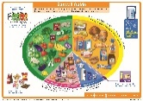

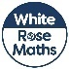
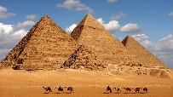
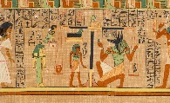
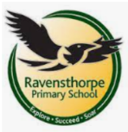
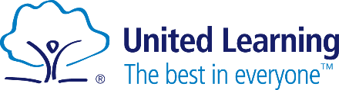
Reading
The story we are reading this term is Marcy and the Riddle of the Sphinx by Joe Todd-Stanton. This adventure story focuses on Marcy going on a rescue mission to Egypt to save her father from the cultures of the Great Sphinx.
Please remember reading diaries and books need to be in every day.
PSHE
This term we will be focusing on personal safety:
- Understand safety rules and who to tell.
- Identify and name body parts
- Identify and distinguish ‘yes’ and ‘no’ touches.
- Distinguish between ‘good’ and ‘bad’ secrets.
- Recognise between bribes and tricks.

Writing
This term we are writing our own ending to the narrative Marcy and the Riddle of the Sphinx. We are continuing to use our descriptive language like adjectives and adverbs to make our writing more interesting.
Later in the term, we are creating a non-chronological report about Ancient Egypt.
Science
In science we are focusing on biology – learning about our body. We will be focusing on a healthy diet, learning about our skeletons and discovering the purpose of our organs. Later on, we will be comparing the human body to other animals.

Religious Education
In RE we are focusing on morals:
- What are moral decisions?
- Where do rules come from?
- What are good intentions?
- What are religious and non-religious views?

Maths
This term Year 3 are focusing on:
- Multiplying and dividing by 8.
- Multiples of 10
- Related calculations
- Reasoning about multiplication
- Multiplying a 2-digit by a 1-digit number
- Multiplying a 2-digit by a 1-digit number with regrouping.
- Dividing a 2-digit number by a 1-digit number.
By the end of this half term, children need to be confident in their 2, 5, 10, 3, 4 and 8 times tables. Extra practice at home is appreciated!
Computing and Keeping Safe
This term in computing, we are going to use a range of techniques to create a stop-frame animation on our iPads.
Keeping Safe lessons are focusing on how an online reputation can be built when posting information online.

Key Theme
Ancient Egypt

Ancient Egypt
In our history lesson we are focusing on:
- Where and when was Ancient Egypt?
- The importance of the Nile
- Who ruled the Ancient Egyptians?
- What were the Ancient Egyptians beliefs?
- What did they develop?
- How did Egypt grow and shrink?
- Why was the pharaoh so powerful?

School: Ravensthorpe Primary School
Class name: Golden and Spotted Kestrels

