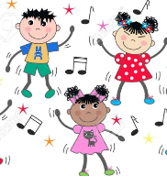
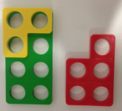
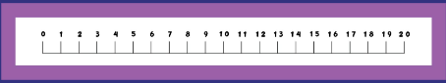
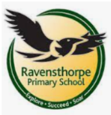
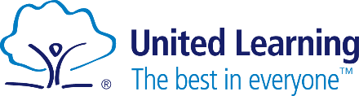
Maths
We are currently learning Place Value to 20.
We will be able to know how many tens and ones are in a given number to 20. We will be able to complete a number line and estimate on a number line to 20.
Later on in the term we will focus on adding and subtracting within 20. We will be able to double numbers to ten and complete number bonds to 20. This will help us to complete number problems.

To become a maths whiz we can practice our
number bond for numbers up to ten at home.

Key Theme
Here I am in Peterborough, where we are UK
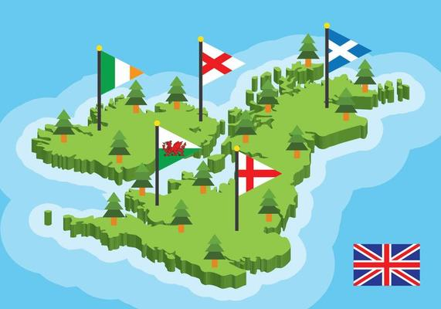

Personal, Social and Emotional Development
Our topic is Drug Education, we will be learning…
- Medication - what is safe and unsafe to access without an adult.
- Other substances – the safety around household cleaning products.
- Risk, Influences and Support – know how to handle risky situations.

Reading
We are exploring some exciting books;
- Traction man – a classroom favorite, looking at how our superhero traction man will save the day.
- Coming to England – Following two sisters as they set sail from Trinidad to London.
- The Three Little Pigs – A much loved traditional tale about three pigs setting up home in the big wide world.

Writing
At the beginning of this term we are looking at the Naughty Bus. We will be retelling the story and then innovating it to create a different version.
At the end of the term we will be looking at Lost and Found, we will be creating instructions using our imperative verbs. The children will be able to continue this after the half term.

Religious Education
Within our Religious Education studies we have been learning about Judaism and Christianity. This term we are looking at who they believe to have made the world and who is responsible for looking after our world.

Physical Education
Our focus in PE is dance and fitness, we are learning how to control our movements and move in time with the rhythm.

Geography
We are learning about our local area of Peterborough and the United Kingdom.
- What is a settlement? (Village, town and City)
- How maps are created using plan view.
- Be able to create our own maps and give directions.
- Be able to identify human and physical features.
- To know the UK is made of four countries: England, Scotland, Wales and Northern Ireland and their capitals.
- To identify key features that makes a settlement rural and coastal.

Computing
Using laptops, we are learning how we can write using technology. We will be…
- Exploring the keyboard
- Adding and removing text
- Exploring the toolbar
- Making changes to text
- Explaining my choices
- Pencil or Keyboard

Art
Using paper will be creating sculptures learning about:
- Creating patters using pencils and pens comparing their effect.
- American artist Charles McGee known for his paintings and sculptures.
- Creating our own paper sculptures.

School: Ravensthorpe Primary School
Class name: Red Kites and Yellowbill Kites

