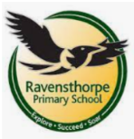

Key Theme
Castles, Knights and Dragons
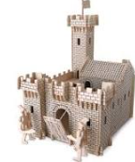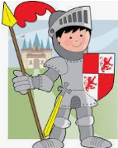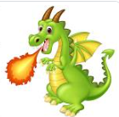

Writing 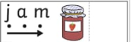
- Innovate a story using a story map (change elements to make it your own).
- Write simple labels.
- Write words using sounds taught in phonics.
- Write a simple list using phonics to sound out words.
- Say simple captions and sentences out loud and write these using phonetically plausible sounds.

Physical Development 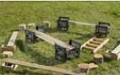
- Use large outdoor construction materials to build own castle.
- Use apparatus in different ways to travel over, under or around.
- Use construction materials to build a dragon’s nest.
- Create models from playdough/salt dough.
  - Take part in a variety of fine motor activities including using chopsticks!

Expressive Arts and Design
- Sing and perform nursery rhymes
- Create dragon pictures and create texture by using different techniques e.g.: textured paint.
- Develop storylines in their pretend play e.g.: dragon’s kitchen themed role play.
- Use junk modelling to build castles, crowns & dragons.

Understanding the World
- Compare photographs from present day and the past.
- Learn about modern day and historic kings and queens and their roles.
- Compare and contrast characters from stories, including figures from the past.
- Understand who lives in a castle and what a monarch is.
- Recognise that people have different beliefs and celebrate special times in different ways e.g.: Chinese New Year.

Maths
- Introducing Zero: Know that the word ‘zero’ and the numeral 0 represent ‘nothing there’.
- Find, subitise and represent numbers from 0-5
- Compare numbers to 5: Make comparisons between groups of 0-5 objects and know 1 more and 1 less.
- Compare weight and capacity: Compare mass and capacity using appropriate mathematical vocabulary.
- Recognise 6, 7 and 8 by counting or subitising
- Making Pairs: Understand that a pair is 2 and notice when some quantities have an odd one out
- Combining 2 groups to find out how many altogether
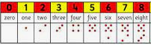

Reading
- Reading the following key texts as a class: Selection of non-fiction texts about castles,
- After the Fall by Dan Santat
- George and the Dragon by Christopher Wormell.
- The Knight who said no by Lucy Rowland
- Know the meaning of new vocabulary e.g.: tower, turret, stone, bricks, drawbridge, portcullis, moat.
- Retell a story using a story map.
- Make predictions about what will happen next.
Communication and Language

- Make simple predictions about what will happen next.
- Retell a story using both actions and words.
- Listen carefully and learn rhymes, poems and songs.

Personal, Social and Emotional Development
- Discuss what it means to be a good friend
- Listen to stories about brave and not so brave knights, identify what bring brave means.
- Build castles cooperatively with peers.
- Work with a friend to plan out a challenge
- Develop resilience and perseverance in the face of challenge
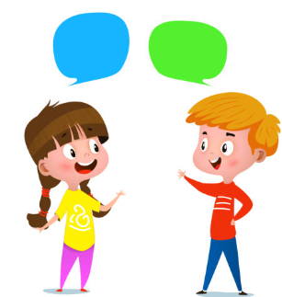

School: Ravensthorpe Primary School
Class name: Snowy and Barn Owls

